**Practical – 2**

**1. Log on to Oracle**

Connect system /password@database

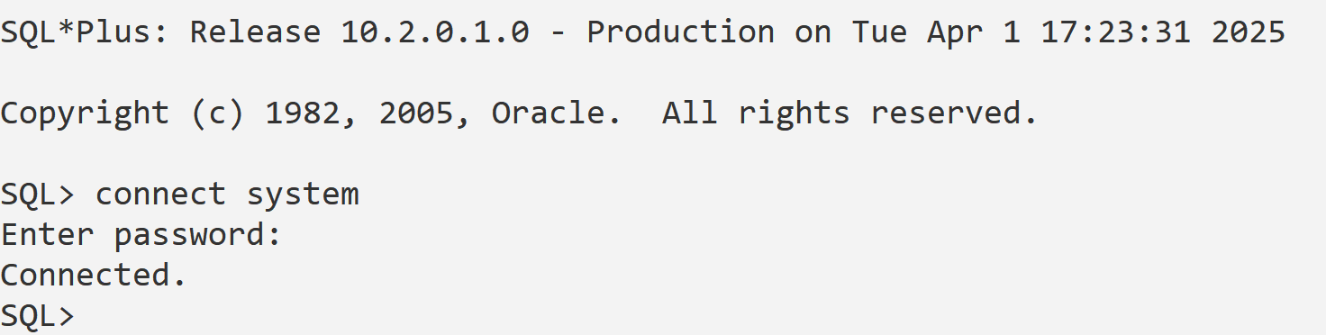

**2. See list of tables**

SELECT * FROM tab; -- Shows all user tables

SELECT * FROM user_tables;

SELECT * FROM cat; -- Another way to list tables

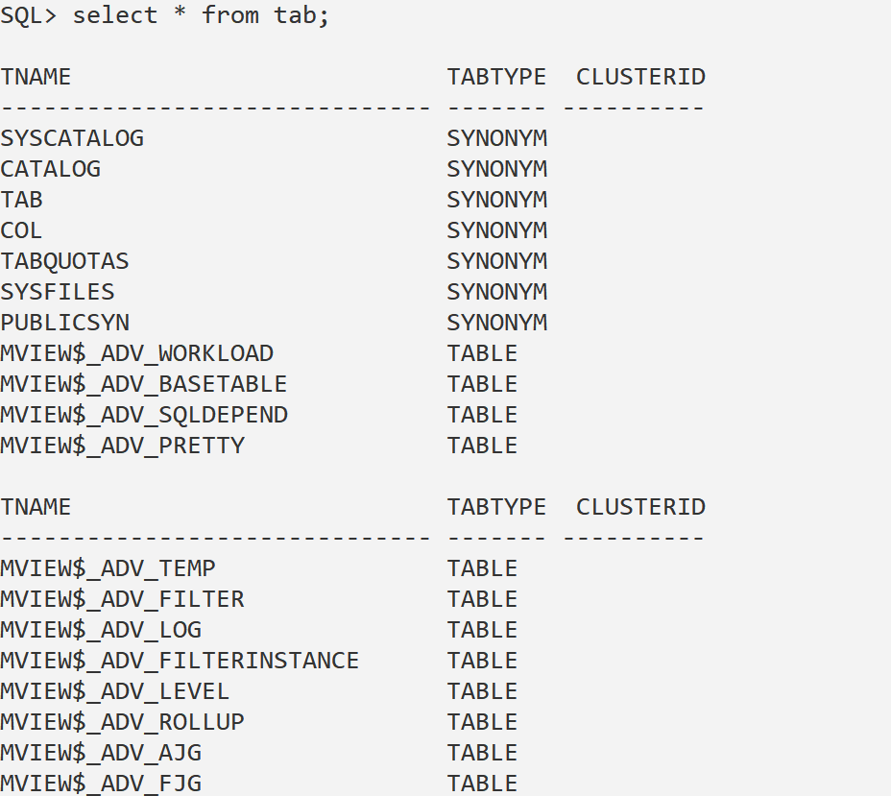

**3. View the user name from DUAL and by SHOW USER**

SELECT USER FROM DUAL; -- Retrieves the current user

SHOW USER; -- Displays the connected user

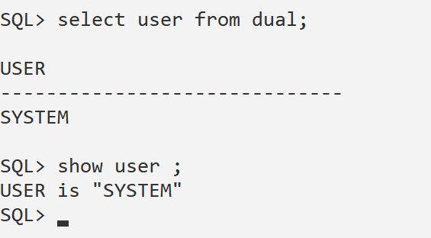

**4. View today's date**

SELECT SYSDATE FROM DUAL;

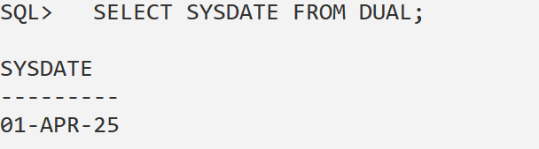

**5. Clear the screen**

CLEAR SCREEN;

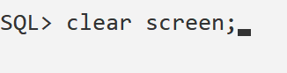

**6. See the list of all environment variables & set page size**

SHOW ALL; -- Shows all environment variables

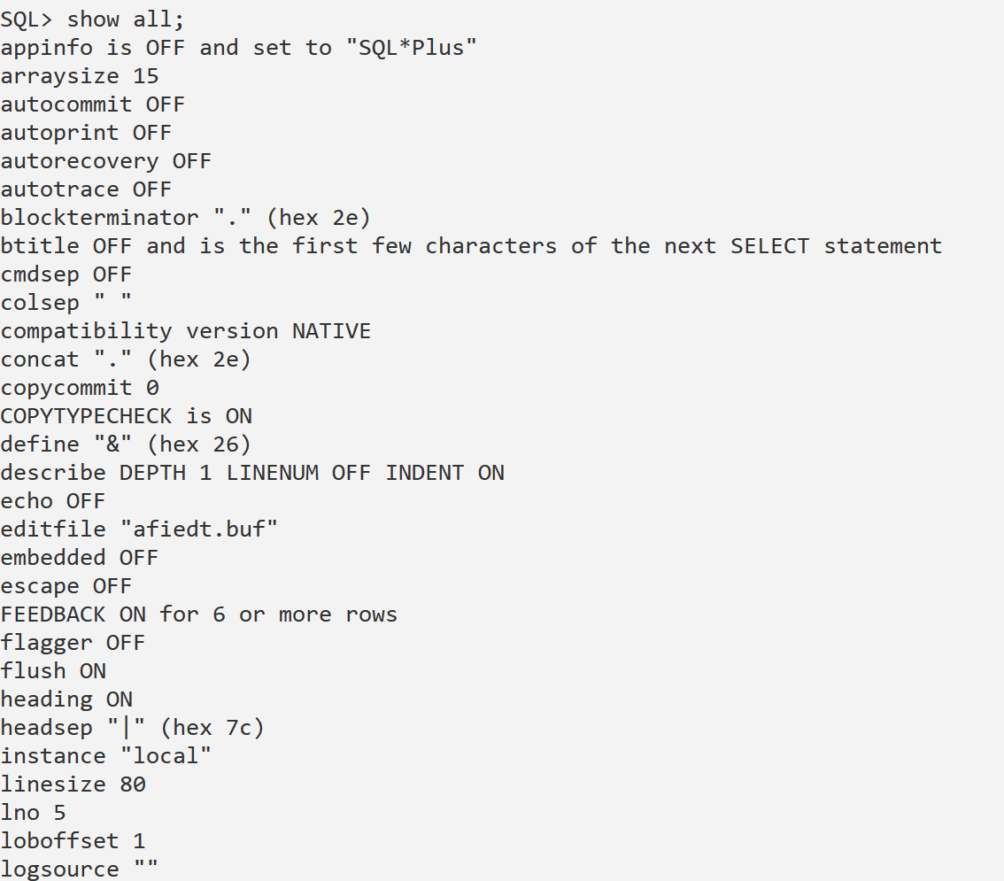

**SET PAGESIZE 100; -- Sets the page size to 100**

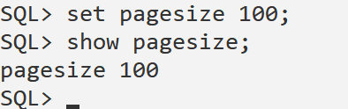

**7. Perform mathematical operations using DUAL**

SELECT 10 + 5 AS Addition FROM DUAL; -- Addition

SELECT 10 * 5 AS Multiplication FROM DUAL; -- Multiplication

SELECT 20 - 3 AS Subtraction FROM DUAL; -- Subtraction

SELECT 100 / 5 AS Division FROM DUAL; -- Division

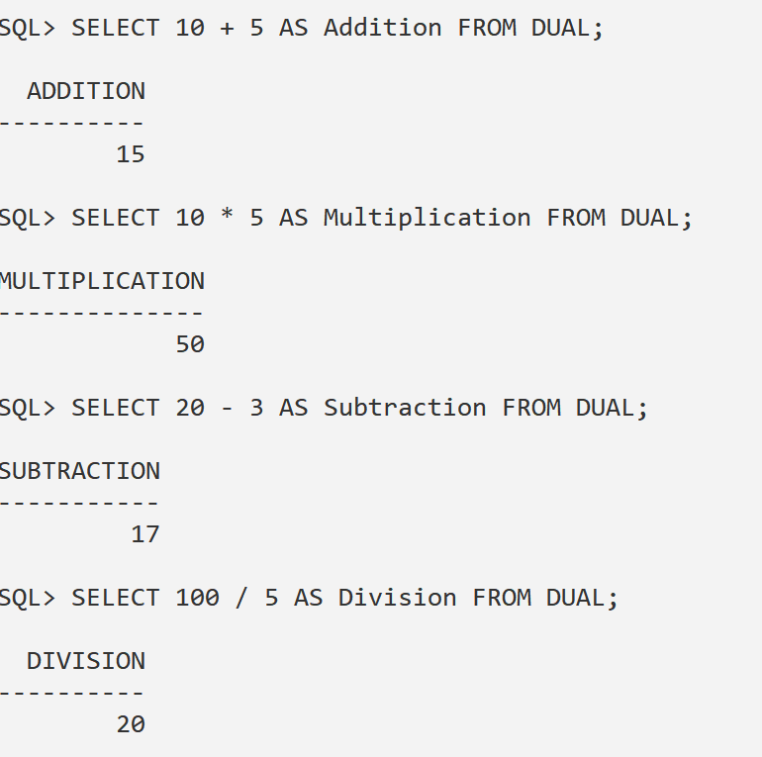

**8. Clear the screen**

CLEAR SCREEN;

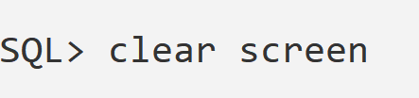

**9. See all records from a table (Example:** Employees**)**

SELECT * FROM Employees;

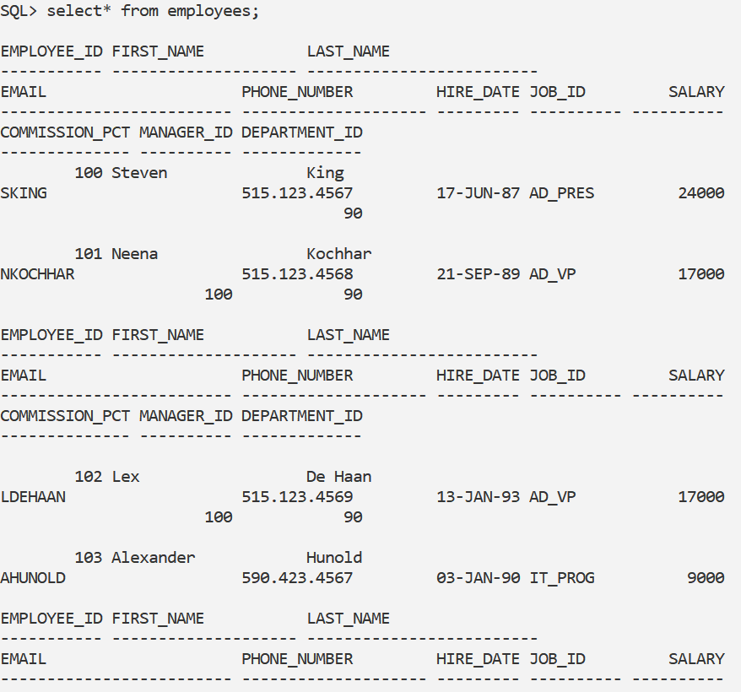

**10. Set linesize to 20**

SET LINESIZE 20;

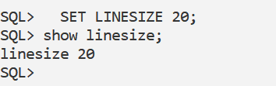

**11. Set linesize to 500**

SET LINESIZE 500;

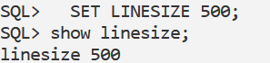

**12. Set pagesize to 7**

SET PAGESIZE 7;

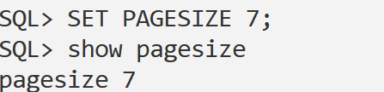

**13. Set pagesize to 200**

SET PAGESIZE 200;

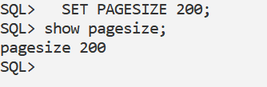

**14. Set heading off (Hide column names)**

SET HEADING OFF;

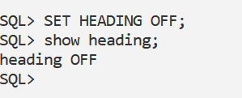

**15. Set heading on (Show column names)**

SET HEADING ON;

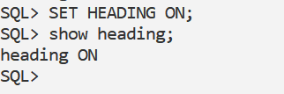

**16. Show user name again**

SHOW USER;

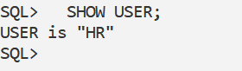

**17. Disconnect from Oracle**

DISCONNECT;

EXIT;

